1. INTRODUCTION
Car Pooling is an intranet Application that commonly known as car-sharing or ride-sharing or lift-sharing is a concept in which commuters share a car while travelling. Participants in Carpooling share journey expenses such as fuel, tolls etc, which reduces the expenses incurred on each participant.
1.1 Purpose
The purpose of the project is to help people in finding car pool. Nowadays traffic has increased so much in our cities that driving for long hours to the office has become really stressful. Carpooling is a good way to overcome this problem, in this four or more persons can create a carpool group and take turns in taking their respective vehicles to work. This not only takes off the load of driving to work every day but also effectively reduces one’s fuel cost and also pollution. Our aim is to provide an intranet application which would help the employees within a company to make use of the car pooling facility effectively and organize their car pools effectively.
  - Existing System
In existing system they are using cab service and Bus provided by Companies. It will be available only in the limited timings and to limited places. Otherwise an employee uses the public transport vehicles. These transportations are very congested, will not be operated in regular timings and not safe for employees who can travel at late time.
  - Literature survey
J2EE:
The J2EE Connector Architecture defines a standard architecture for connecting the J2EE platform to heterogeneous EISs. Examples of EISs include ERP, mainframe transaction processing, database systems, and legacy applications not written in the Java programming language. The J2EE Connector architecture enables an EIS vendor to provide a standard resource adapter for its EIS. The resource adapter plugs into an application server, providing connectivity between the EIS, the application server, and the enterprise application. If an application server vendor has extended its system to support the J2EE Connector architecture, it is assured of seamless connectivity to multiple EISs.
About J2EE: J2EE leaped onto the scene in 1999. Considering the historical context of this product release you find that the cost of creating, deploying, and maintaining PC-based client/server software was becoming increasingly expensive. Partly in response to this, interest in the Internet and Web applications had been gathering steam for several years. Java had been released only 4 years earlier and continued to demonstrate value in cross-platform development.
J2EE Development: The Java development team at Sun Microsystems saw several opportunities in this environment. First, the conglomeration of APIs and standards that was Java could be organized in such a way that it would be easier for developers to build applications, specifically Web applications, with Java. Second, Java could make more inroads in middleware development with a clear and consistent middleware standard. And third, the various Java technologies that were currently being used to develop Web applications could be combined with the middleware APIs to create a convenient package for developers to use to create applications. The result of this repackaging and branding exercise was the J2EE released in December 1999.
J2EE Component: This ability to build applications with components provides a great deal of flexibility in constructing and deploying an application and is one of the primary reasons for the interest in J2EE technology. A distributed component can be deployed on a single server and made available to multiple applications that have access to the server. The component can thus be deployed in a centralized fashion, allowing information technology (IT) management control over the operating environment of the critical business services provided by the application components.
Java Development Kit (JDK) was split into three parts: Java 2 Standard Edition (J2SE), Java 2 Enterprise Edition (J2EE), and the Java 2 Micro Edition (J2ME). This split provided a convenient repackaging of the myriad APIs that was Java. What is confusing in relation to J2EE is that the J2SE is part of the J2EE release. In order to run the J2EE, the J2SE must be installed. To avoid this confusion, you should think of the J2SE as the core Java installation component. J2EE is built on the J2SE.

J2EE Application:
J2EE application is composed by:
- Enterprise beans.
- Web client component modules.
- All related files as
- Graphics files (GIF, JPG)
- HTML files.
- A deployment descriptor: an app_name. Xml that was read at runtime by the J2EE server.
Advantages of an application model J2EE:
- Through a set of specifications and several technologies J2EE platform offers several benefits in developing distributed applications.
- Simplified development.
- Integration with existing information systems.
- Write-once-run anywhere.
JSP:
Java Server Pages (JSP) lets you separate the dynamic part of your pages from the static HTML. You simply write the regular HTML in the normal manner, using whatever Web-page-building tools you normally use. You then enclose the code for the dynamic parts in special tags, most of which start with "<%" and end with "%>". For example, here is a section of a JSP page that results in something like "Thanks for ordering” You normally give your file a .jsp extension, and typically install it in any place you could place a normal Web page. Although what you write often looks more like a regular HTML file than a servlet, behind the scenes, the JSP page just gets converted to a normal servlet, with the static HTML simply being printed to the output stream associated with the servlet service method. This is normally done the first time the page is requested.
Basics: Java Server Pages (JSP) provide a facility whereby you can write sever-side scripted pages using the full power of the Java programming language and the rich set of class libraries associated with Java. However there is a price to pay in that JSP, like most things to do with Java, is significantly more complex than other techniques.
How JSP works: JSP pages are, at first glance, rather similar to ASP and PHP pages in that special pseudo-tags are used to mark out parts of otherwise normal HTML pages that are to handled specially. The difference is that, whereas ASP and PHP are processed by a server plug-in, JSP is handled by a separate server process. For JSP this process runs software known as Tomcat which takes the JSP page and converts the entire page into a Java programme which is then compiled. The raw HTML in the original page is wrapped in Java output methods. On requesting a JSP page, the request is transferred from the normal WWW server (e.g. Apache) to Tomcat which first checks whether it has cached an already compiled version of the Java programme associated with the page. Recompilation takes place if the last modification date stamp on the JSP page is more recent than the last modification date stamp on any cached compiled version.
Javascript:
JavaScript is a script-based programming language that was developed by Netscape Communication Corporation. JavaScript was originally called Live Script and renamed as JavaScript to indicate its relationship with Java. JavaScript supports the development of both client and server components of Web-based applications. On the client side, it can be used to write programs that are executed by a Web browser within the context of a Web page. On the server side, it can be used to write Web server programs that can process information submitted by a Web browser and then update the browser’s display accordingly.
Even though JavaScript supports both client and server Web programming, we prefer JavaScript at Client side programming since most of the browsers supports it. JavaScript is almost as easy to learn as HTML, and JavaScript statements can be included in HTML documents by enclosing the statements between a pair of scripting tags.
<SCRIPT>...</SCRIPT>.
<SCRIPT LANGUAGE = “JavaScript”>
JavaScript statements
</SCRIPT>
Here are a few things we can do with JavaScript:
Validate the contents of a form and make calculations.
Add scrolling or changing messages to the Browser’s status line.
Animate images or rotate images that change when we move the mouse over them.
Detect the browser in use and display different content for different browsers.
Detect installed plug-ins and notify the user if a plug-in is required.
We can do much more with JavaScript, including creating entire application.
JavaScript Vs Java: JavaScript and Java are entirely different languages. A few of the most glaring differences are:
Java applets are generally displayed in a box within the web document; JavaScript can affect any part of the Web document itself.
While JavaScript is best suited to simple applications and adding interactive features to Web pages; Java can be used for incredibly complex applications.
There are many other differences but the important thing to remember is that JavaScript and Java are separate languages. They are both useful for different things; in fact they can be used together to combine their advantages.
Advantages: JavaScript can be used for Sever-side and Client-side scripting.
It is more flexible than VBScript.
JavaScript is the default scripting languages at Client-side since all the browsers supports it.
Hyper Text Markup Language (HTML):
Hypertext Markup Language (HTML), the languages of the World Wide Web (WWW), allows users to produces Web pages that include text, graphics and pointer to other Web pages (Hyperlinks).
HTML is not a programming language but it is an application of ISO Standard 8879, SGML (Standard Generalized Markup Language), but specialized to hypertext and adapted to the Web. The idea behind Hypertext is that instead of reading text in rigid linear structure, we can easily jump from one point to another point. We can navigate through the information based on our interest and preference. A markup language is simply a series of elements, each delimited with special characters that define how text or other items enclosed within the elements should be displayed. Hyperlinks are underlined or emphasized works that load to other documents or some portions of the same document.
HTML can be used to display any type of document on the host computer, which can be geographically at a different location. It is a versatile language and can be used on any platform or desktop.
HTML provides tags (special codes) to make the document look attractive. HTML tags are not case-sensitive. Using graphics, fonts, different sizes, color, etc., can enhance the presentation of the document. Anything that is not a tag is part of the document itself.
Advantages: A HTML document is small and hence easy to send over the net. It is small because it does not include formatted information.
HTML is platform independent.
HTML tags are not case-sensitive.
Oracle Database:
An Oracle database is a collection of data treated as unit. The purpose of a database is to store and retrieve related information. A database server is the key to solving the problems of information management. In general, a server reliably manages a large amount of data in a multiuser environment so that many users can concurrently access the same data. All this accomplished while delivering high performance. A database server also prevents unauthorized access and provides efficient solutions for failure recovery.
Oracle database is the first database designed for enterprise computing, the most flexible and cost effective way to manage information and applications. Enterprise grid computing creates large pools of industry-standard, modular storage and servers. With this architecture, each new system can be rapidly provisioned from the pool of components. There is no need for peak workloads, because capacity can be easily added or reallocated from the resource pool as needed.
The grid style of computing aims to solve some common problems with enterprise IT: the problem of application silos that lead to underutilized, dedicated hardware resources, the problem of monolithic, unwieldy systems that are expensive to maintain and difficult to change, and the problem of fragmented and disintegrated information that can be fully exploited by the enterprise as a whole.
The Oracle Database 10g family of software products implements much of the core grid technology to get companies started. And oracle delivers this grid computing functionality in the context of holistic enterprise architecture, providing a robust security infrastructure, centralized management, intuitive, powerful development tools, and universal access. This includes:
Oracle Database 10g
Oracle Application Server 10g
Oracle Enterprise Manager 10g
Oracle Collaboration Suite 10g
Although the grid features of Oracle 10g span all the products listed above, this discussion will focus on the grid computing capabilities of Oracle Database 10g.
JDBC Architecture:
With JDBC, the application programmer uses the JDBC API. The developer never uses any proprietary APIs. Any proprietary APIs are implemented by a JDBC driver. There are 4 types of JDBC Drivers:
There are 4 types of JDBC Drivers
- Type 1 - JDBC-ODBC Bridge
- Type 2 - JDBC-Native Bridge
- Type 3 - JDBC-Net Bridge
- Type 4 - Direct JDBC Driver
Type 1 only runs on platforms where ODBC is available. ODBC must be configured separately.
Type 2 Drivers map between a proprietary Database API and the JDBC API.
Type 3 Drivers are used with middleware products.
Type 4 Drivers are written in Java.

1.4 Proposed System
Carpooling allows sharing the cost of fuel, maintenance and parking, cutting the expenses by nearly 50% or more. Carpooling is also socially economical.
1. To maintain a web based intranet application that enables the employee within an organization to avail the facility of carpooling effectively.
2. Each and every employee can register on to the website providing his name, contact number and employee id.
3. Employees can be drivers as well as only passengers.
4. Once the registration is done, then based on your route, and shift timings, the website will provide you the list of opted members automatically who can be on your car pool and you can be approved.
5. The employee can check the authenticity of the vehicle details and the owner’s license which would help in developing trust and opt the willing carpool.
6. A car pool group can have minimum of 4-5 members including the driver.
7. The employee can be involved in only one car pool.
8. One route can have many car pools.

2. Requirements Analysis
2.1 Functional Requirements
2.1.1 Admin
The admin can log in into the system and can update the database if there are any changes and the admin has the right to maintain the data base.
2.1.1.1 Process Flow:
- Administrator Login.
- Adding employees to Database.
- Updating Employee Details.
- Deleting the Employee.
- Approving car pool.
2.1.2 Employee
The employee can log in and search for the required pool he wants and sends a request to that particular pool, if the employee doesn’t find the required pool then he can create his own pool and in both the cases the employee can view the profile.
2.1.2.1 Process Flow:
- Employee need to register with his employee id.
- Employee Login.
- Create car pool
- Search for car pool
- Join car pool
- View car pool owner details
- View car pool member details
- Each Employee can join in only one carpool.

2.2 Tools & Technology Requirements
- JAVA: Java is an object-oriented programming language developed by Sun Microsystems a company best known for its high end UNIX workstations. Java language was designed to be small, simple, and portable across platforms, operating systems, both at the source and at the binary level, which means that Java programs (applet and application) can run on any machine that has the Java virtual machine (JVM) installed.
- J2EE: Java Platform, Enterprise Edition or Java EE is a widely used platform for server programming in the Java programming language. The Java platform (Enterprise Edition) differs from the Java Standard Edition Platform (Java SE) in that it adds libraries which provide functionality to deploy fault-tolerant, distributed, multi-tier Java software, based largely on modular components running on an application server.
- Development tool –RAD: IBM Rational Application Developer for Web Sphere Software (RAD) is an integrated development environment (IDE), made by IBM's Rational Software division, for visually designing, constructing, testing, and deploying Web services, portals, and Java (J2EE) applications.
- Database platform – DB2: DB2 Database is the database management system that delivers a flexible and cost effective database platform to build robust on demand business applications and supports the J2EE and web service standards.
Design tool – Rational Software Modeler IBM Rational Software Modeler, (RSM) made by IBM's Rational Software division, is a Unified Modeling Language.
UML 2.0: Based visual modeling and design tool. Rational Software Modeler is built on the netbeans open-source software framework and includes capabilities focused on visual modelling and model-driven development (MDD) with the UML for creating resilient, thought-out applications and web services.

2.3 Hardware Requirements
Processor : Intel P-IV based system
Processor Speed : 2.0. GHz
RAM : 256 MB to 512 MB
Hard Disk : 40GB to 80GB
Input device : Standard Keyboard and Mouse
Output device : High resolution monitor

2.4 Deployment Requirements
Editor: Netbeans
Server: Apache Tomcat 5.0
Database: To store the data given by the user. Oracle database is used.

2.5 Quality Requirements
2.5.1 Performance:
It is the response time, utilization and throughput behavior of the system. Care is taken so as to ensure a system with comparatively high performance.
2.5.2 Maintainability:
All the modules must be clearly separate to allow different user interfaces to be developed in future. Through thoughtful and effective software engineering, all steps of the software development process will be well documented to ensure maintainability of the product throughout its life time. All development will be provided with good documentation

2.5.3 Usability:
The ease of use and training the end users of the system is usability. System should have qualities like- learning ability, efficiency, affect, control. The main aim of the project is to reduce server failure and get high performance of server and reduce the rework of the programmer.
2.5.4 Availability:
Availability is suitable or ready to use. This project has 24*7 availability.
.

3. Architecture
  - System Architecture:
Project architecture represents number of components we are using as part of our project and the flow of request processing i.e what components in procession the request and in which order. An architecture description is a formal description and representation of a system, organized in a way that supports reasoning about the structure of the system. Architecture is of two types. They are
System architecture
(2)Technical architecture
Car pooling
Application

Admin

Login
Employee
Registration
Login
Add employee
View employees
Delete employees
Accept/Reject carpool

Database
Create carpool
Searches for carpool
Joins the carpool
Deletes from Carpool

Logout
Logout

Fig 3.1 System Architecture

3.2 Technical Architecture
The basic structure of the system follows a Layered Architecture. A number of different layers are defined, each accomplishing operation that progressively become closer to the machine instruction set.
These are the layers under which the architecture is characterized:

- Data Access Layer:
It contains the data needed for the application. This layer will interact with database.
- Business Logic Layer:
This layer models the system rules, often through the interaction with the application’s data.
- Presentation Layer:
It defines what the user interface displays and how the user’s request is handled. Depending on what user interfaces are supported the application may need to have slightly different versions of presentation of logic to the client appropriately.

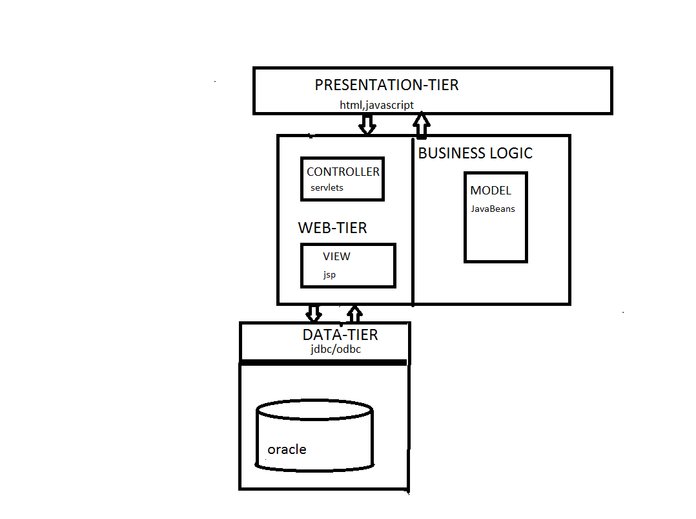
Fig 3.2 Technical Architecture
4. DESIGN
4.1 Use Case Diagram:
Use case diagrams display the relationship among actors and usecase. A use case diagram is a set of scenarios that describe an interaction between a user and a system. The two main components of the use case diagrams are use cases and actors.
An actor represents a user or another system that will interact with the system you are modelling. A use case is an external view of the system that represents an action the user might perform in order to complete a task. They are helpful in exposing requirements and planning the project
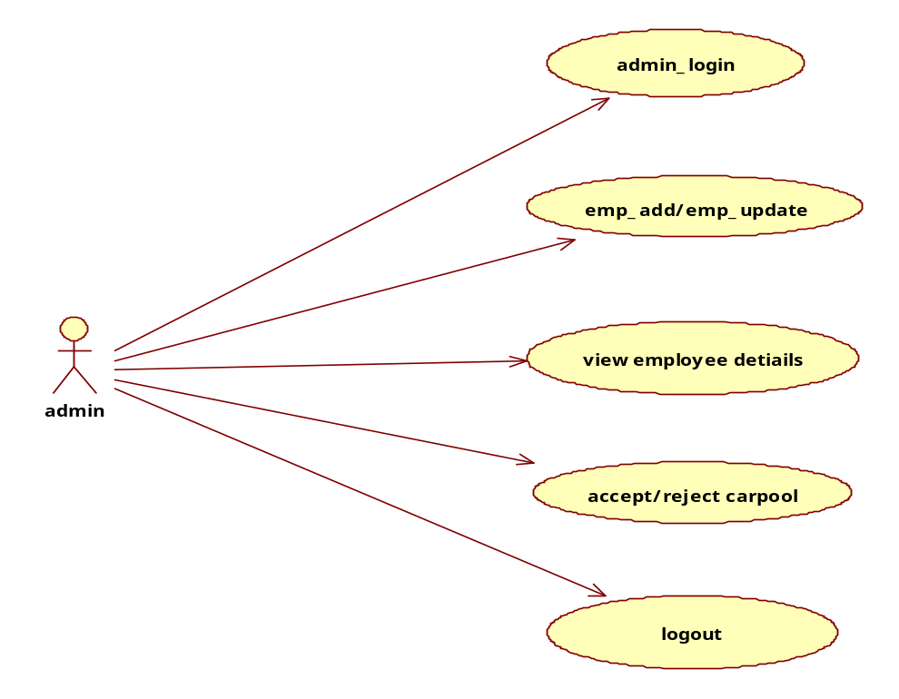
Fig 4.1 Use Case Diagram of Admin

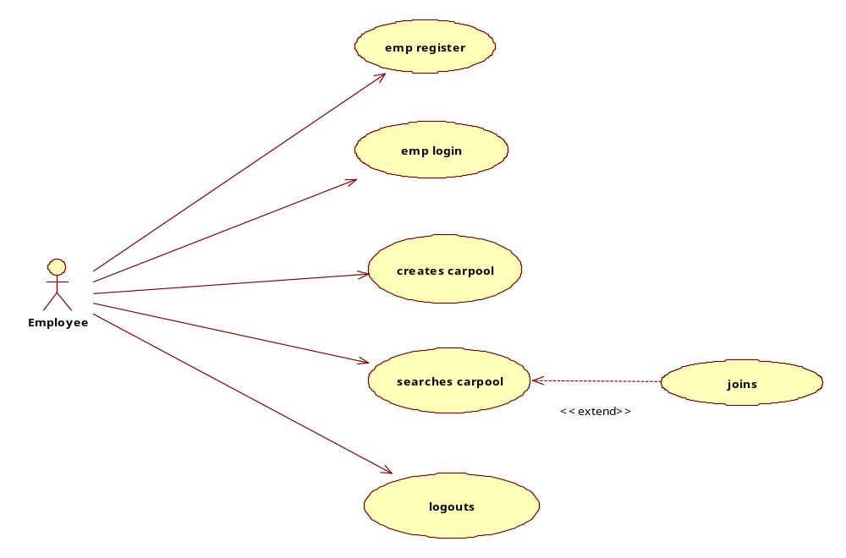
Fig 4.2 Use Case Diagram of Employee

4.2 Activity Diagram:
Displays a special state diagram where most of the states are action states and most of the transitions are triggered by completion of the actions in the source states. This diagram focuses on flows driven by internal processing.
Activity diagrams address the dynamic view of a system. These are especially important in modeling and emphasizes the flow of control among objects.
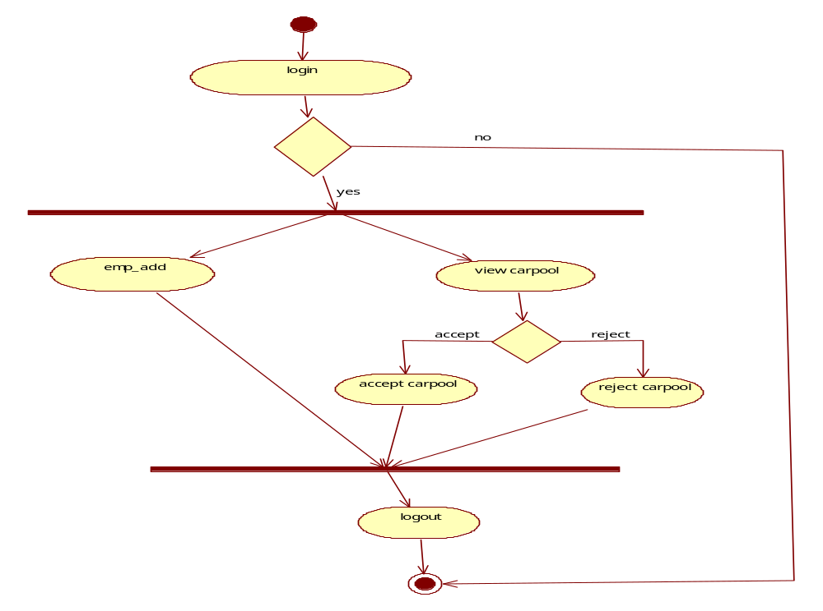
Fig 4.3 Activity Diagram of Admin
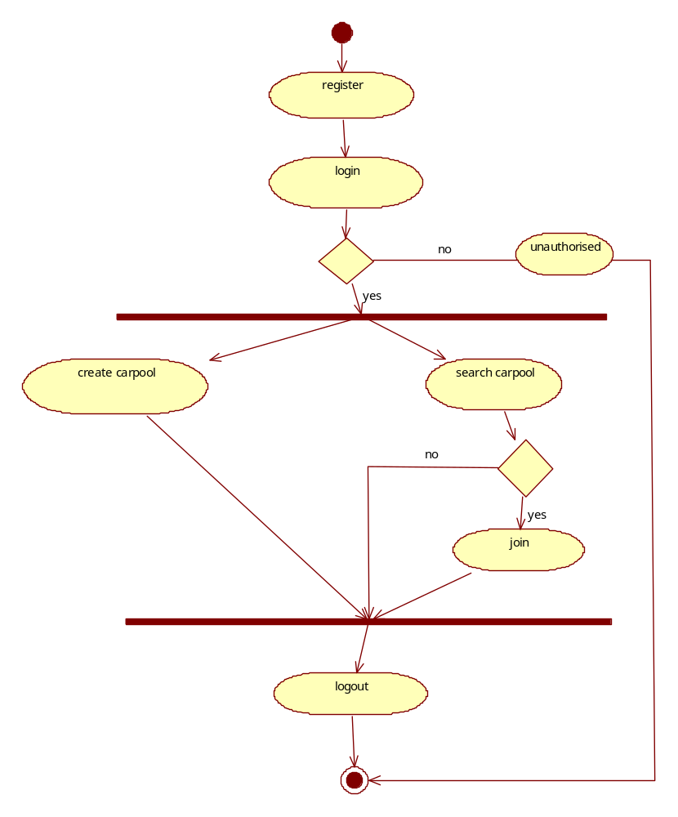
Fig 4.4 Activity Diagram of Employee

4.3 Class Diagram
Class diagram shows set of classes, interfaces, associations, constraints, colloborations and their relationships. Class diagram that includes active classes address the static view. It is also known as structural diagram.
The purpose of class diagram is analysis and design of static view of an application, it describes responsibilities of the system, it is the base for component and deployment diagrams. It is used in forward engineering and reverse engineering.

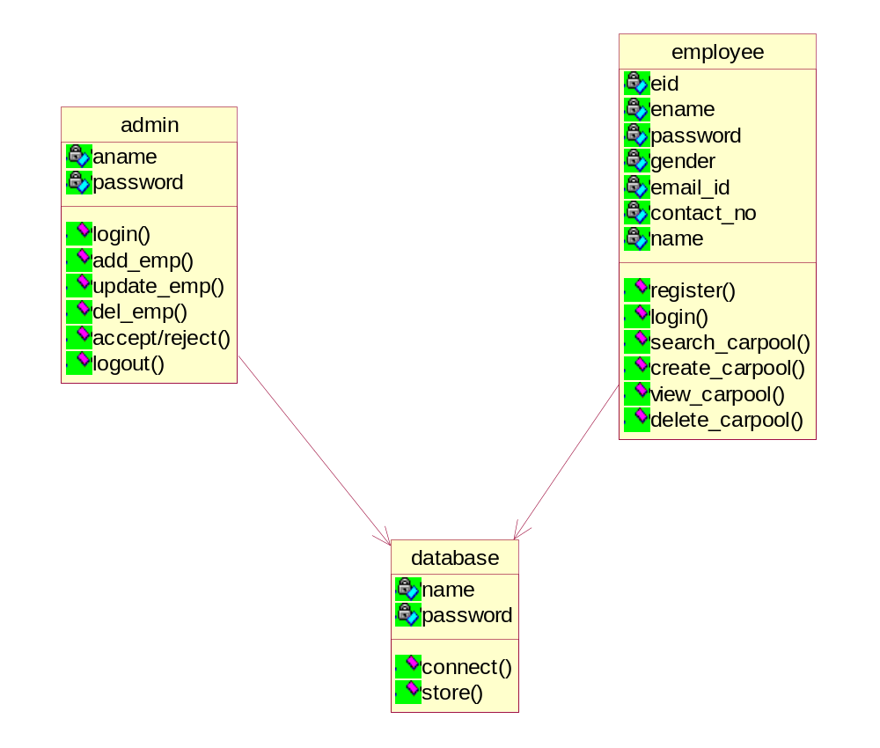
Fig 4.5 Class Diagram

4.4 Sequence Diagram
Displays the time sequence of the objects participating in the interaction. This consists of the vertical dimension (time) and horizontal dimension (different objects).
It is an interaction diagram that emphasizes the time ordering of messages.
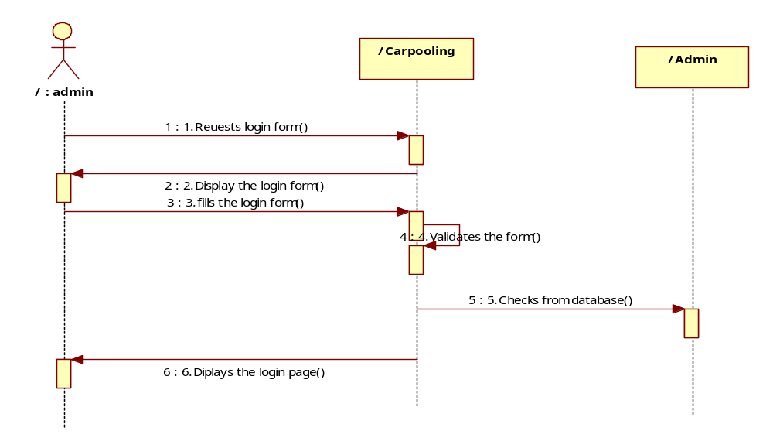
Fig 4.6 Sequence Diagram of Admin Login
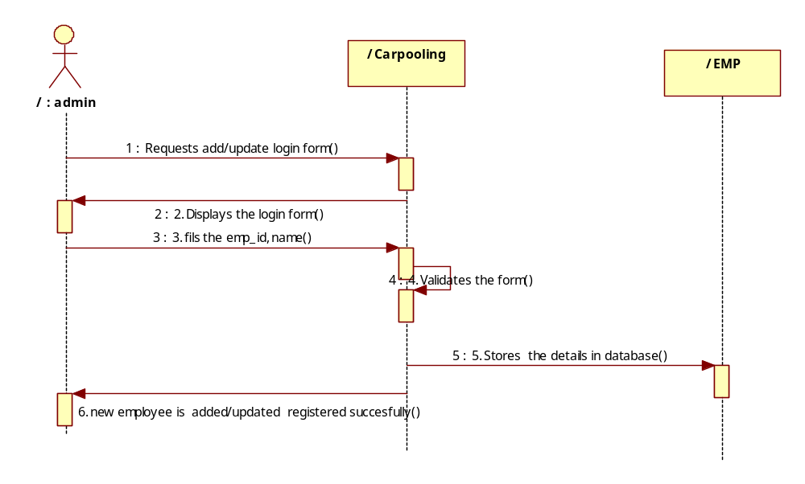
Fig 4.7 Sequence Diagram of Admin Add/Update Employee
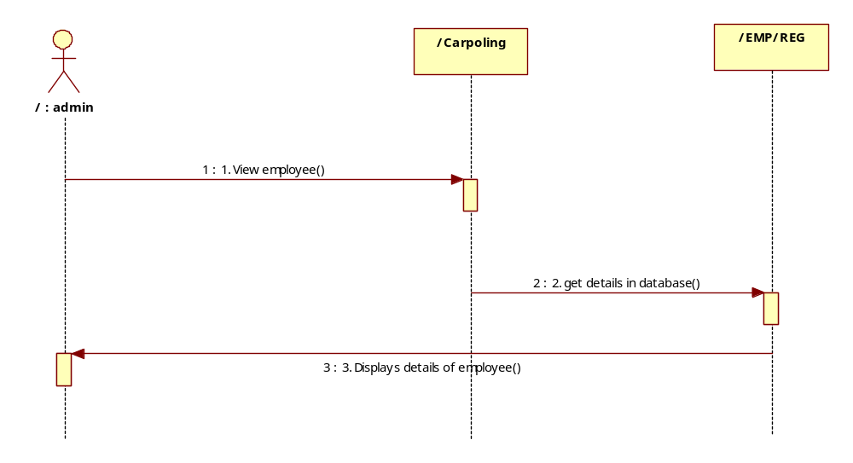
Fig 4.8 Sequence Diagram of Admin View Employee Registration Details
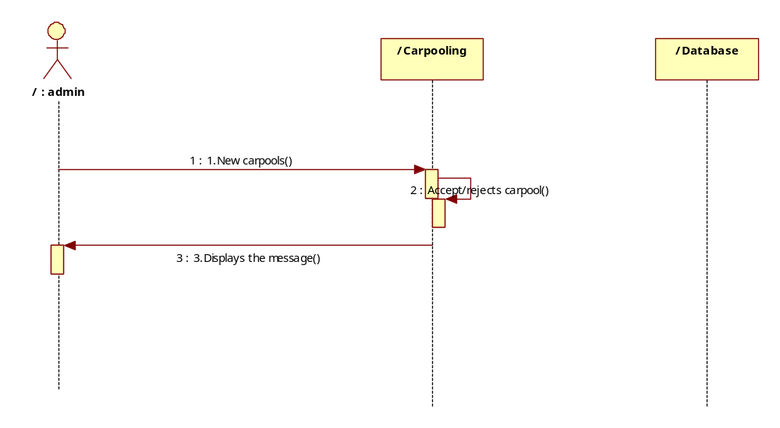
Fig 4.9 Sequence Diagram of Admin Accept/Reject Car pools

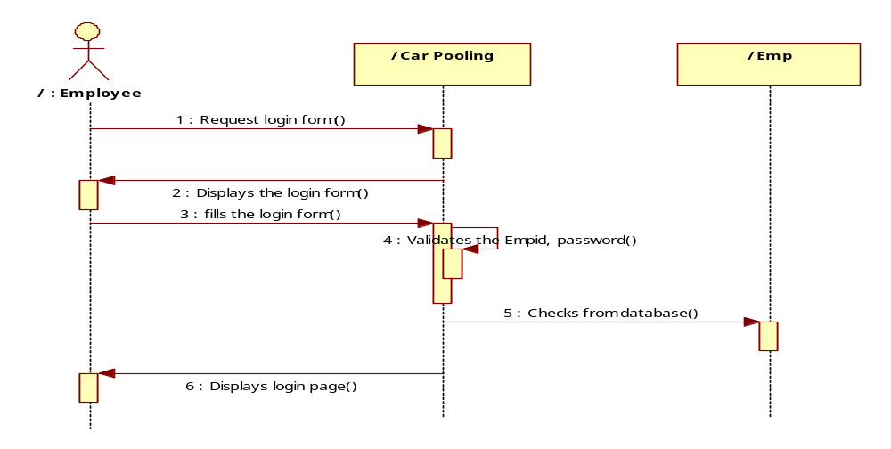
Fig 4.10 Sequence Diagram of Employee Registration

Fig 4.11 Sequence Diagram of Employee Login
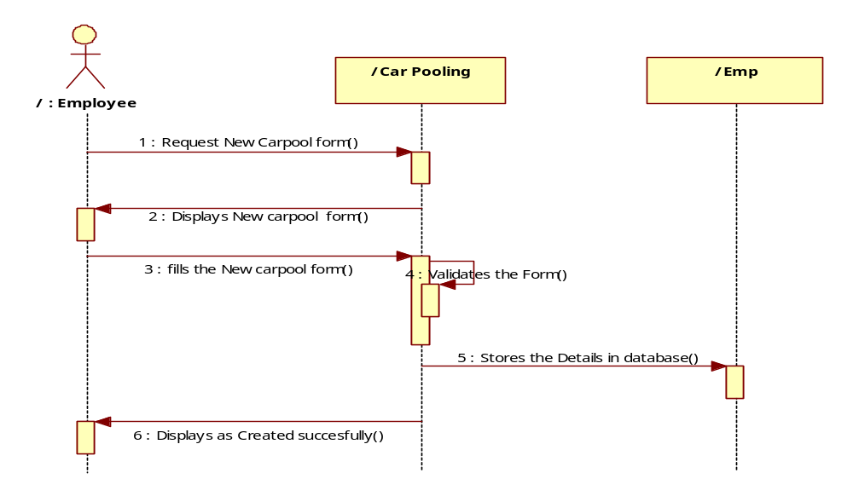
Fig 4.12 Sequence Diagram of Create a Car Pool
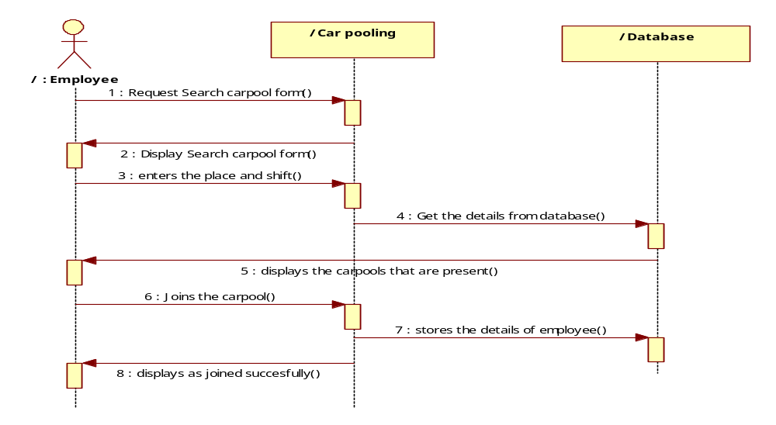
Fig 4.13 Sequence Diagram of Search,Join a Car Pool

  - Database Design-ER Diagram
An ER model is an abstract way to describe a database. Describing a database usually starts with a relational database, which stores data and table. Diagrams created to design the entities and relationships are called Entity Relationship diagrams or ER diagrams.

a_name
vacancies

password
Cp_id
address
V no
authenticates
manages
admin
Employee
Vehicle
passenger
Driver/passenger
destination
Car Pool Pool

Pool details
source
Registers
via
Emp_id
ename
authenticates
V_Type

password
Email_id
V_name
contact

Fig 4.6 ER Diagram

4.5.1 Database Model
A database model is a type of data model that determines the logical structure of a database and fundamentally determines in which manner data can be stored, organized, and manipulated. The most popular example of a database model is the relational model, which uses a table-based format
There are different types of models like
- Relational model
- Hierarchal model
- Network model etc
In our project we use Relational model.
Relational database:
The data in this database is represented in the form of tables with rows and columns. Each column stores an attribute. Each row is a tuple, which stores a single record.
Creating tables using SQL:
Tables are created using with the structured query language. This is the process of creating tables manually with the CREATE DATABASE and CREATE TABLE commands. All the database and tables creation commands should be written with standard ANSI SQL in mind. As an added benefit, using ANSI complaint SQL will ensure that these commands will work on any DBMS that supports the SQL standard, including Oracle and Microsoft SQL server. If you haven't selected a platform for your database yet, the article Database software options walks you through the selection process.
Our first step is to create the database itself. Many database management systems offer a series of options to customize database parameters at this step, but our database only permits the simple creation of a database. As with all of our commands, you may wish to consult the documentation for your DBMS to determine if any advanced.
Our first step is to create the database itself. Many databases management systems offer a series of options to customize database parameters at this step, but our database only permits the simple creation of a database. As with all of our commands, you may wish to consult the documentation for your DBMS to determine if any advanced.
Syntax: CREATE DATABASE database_ name;
We create a table using a command
CREATE TABLE table_name (attribute name datatype, .......attribute name datatype);
We can also specify either NULL or NOT NULL in the options field of the CREATE statement. This simply tells the database whether NULL values are allowed for that attribute when adding rows at the database. NULL is the default value and omitting this option will implicitly allow NULL values for an attribute.
If we need to expand this information we can use a JOIN in our data selection commands to obtain information from multiple tables. This method of storing data reduces redundancy in our database and ensures optimal use of space on our storage drives. We'll cover the JOIN command in-depth in a future.
We can alter the structure after creation of database. However, all is not lost. We can use the ALTER TABLE command to add this attribute to our existing database. Notice that we specified that NULL values are permitted for this attribute. In most cases there is no option when adding a column to a existing table. This is due to the fact that the table already contains rows with no entry for this attribute. Therefore, the DBMS automatically inserts a NULL value to fill the void.
Syntax: ALTER TABLE table_name ADD salary datatype constraint;
To insert values into the table tuples we use insert command
Syntax: INSERT IN TO TABLE table_name values ("v1",...........,"vn");
4.5.1 Table Name,Description and Table Structure with constraints
The total number of database tables that were identified to build the system is 5. The major part of the Database is categorized as.
1. Transactional components:
The Transactional components are useful in recording the transactions made by the system. All the bus requests and cab requests etc information handled by these components.
2. Data Dictionary components:
These components are used to store the major information like Employee details, transport categories, buses details, cabs details, routes details and pickup points information etc.
3. General components:
These components are used to store the general information like login information etc.
4.5.1.1 Table name: Admin
Table Name |  | Admin
Description |  | The admin must login into the page to add, update or delete employee and to approve or reject the carpool.
SNO | Field Name | Data Type | Constraints | Remarks
1 | Uname | Varchar | Not null | Stores the username
2 | Pwd | Varchar | Not null | Stores the password
Table 4.1:Admin Table

4.5.1.2 Table Name: Carpool
Table Name |  | Car Pool
Description |  | This table stores various attributes such as source, destination,vechicle type etc.
SNO | Field Name | Data Type | Constraints | Remarks
1 | Carpool ID | Number | Primary key | Stores carpool id
2 | Employee ID | Varchar2(400) | Primary key | Stores Employee id
3 | Source | Varchar2(400) | Not Null | Stores the source
4 | Dest | Varchar2(400) | Not Null | Stores the  Dest
5 | Via | Varchar2(400) | Not Null | Stores the  Via
6 | Vname | Varchar2(400) | Not Null | Stores the  Vname
7 | Vno. | Varchar2(400) | Not Null | Stores the  Vno.
8 | Vtype | Varchar2(400) | Not Null | Stores the  Vtype
9 | Vacancies | Number | Not Null | Stores the  Vacancies
10 | Lno | Varchar2(400) | Not Null | Stores the  Lno.
11 | Status | Varchar2(400) | Not Null | Stores the  Status
12 | Shift | Varchar2(400) | Not Null | Stores the
Table 4.2 :Carpool

4.5.1.3 Table name: Carpool Members
Table Name |  | Carpool Members
Description |  | This table contains the information about the members who joined in the carpool. It stores the values of attributes like
SNO | Field Name | Data Type | Constraints | Remarks
1 | CP_id | Varchar2(400) | Primary Key | Stores carpool id
2 | Eid | Varchar2(400) | Not null | Stores Employee id
3 | Loc | Varchar2(500) | Not null | Stores the Location
Table 4.3 Carpool Members

4.5.1.4 Table Name: Employee
Table Name |  | Employee
Description |  | This table contains information about the employee who are added by the admin. It contains values of attribute
SNO | Field Name | Data Type | Constraints | Remarks
1 | Empid | Varchar2(100) | Primary Key | Stores employee id
2 | Empname | Varchar2(400) | Not null | Stores Employee name
3 | Gender | Varchar2(100) | Not null | Stores the gender
Table 4.4 Employee

4.5.1.5 Table Name: Employee Register
Table Name |  | Employee
Description |  | The new users need to register before he/she can search or create carpool. Registered user can create, search or join carpool by logging into the user login. The registered values get stored into the database. The table is used to store the values of attributes
SNO | Field Name | Data Type | Constraints | Remarks
1 | Empid | Varchar2(200) | Primary key | Stores employee id
2 | Pwd | Varchar2(300) | Not null | Stores the password
3 | Ename | Varchar2(500) | Not null | Stores Employee name
4 | Gender | Varchar2(100) | Not null | Stores the gender
5 | Contact | Varchar2(100) | Not null | Stores the contact
6 | Email | Varchar2(500) | Not null | Stores the email
7 | Eaddress | Varchar2(1000) | Not null | Stores the address
8 | Cname | Varchar2(200) | Not null | Stores the cname
9 | Caddress | Varchar2(1000) | Not null | Stores the caddress
10 | Website | Varchar2(500) | Not null | Stores the website
Table 4.5 Employee Registration

5.MODULES
5.1 Employee
The employee can log in and search for the required pool he wants and sends a request to that particular pool.
Login: The employee logs in the site using user_ id and password.
Search pool: The employee searches for the suitable pool.
Create carpool: If required the employee creates his own car pool and invites friends to join in.
View Profile: Employee can view other member’s profile.
5.2 Admin
The admin can log in into the system and can update the database if there are any changes regarding the timings of the pool, change in the route, etc and the admin has the right to maintain the data base.
Login: Admin logs in into his account.
View Profile: Views the profile of all the members.
Add Employee: Adds the employee.
Authenticate vehicle: Checks the authorization of the employee and vehicle.
Manage Car Pool: Manages the car pooling database.

6. IMPLEMENTATION
<html xmlns="http://www.w3.org/1999/xhtml">
<head>
<title>Home Page</title>
<meta http-equiv="Content-Type" content="text/html; charset=iso-8859-1" />
<link rel="stylesheet" href="mm_travel2.css" type="text/css" />
<script language="JavaScript" type="text/javascript">
//--------------- LOCALIZEABLE GLOBALS ---------------
var d=new Date();
var monthname=new Array("January","February","March","April","May","June","July","August","September","October","November","December");
//Ensure correct for language. English is "January 1, 2004"
var TODAY = monthname[d.getMonth()] + " " + d.getDate() + ", " + d.getFullYear();
//--------------- END LOCALIZEABLE ---------------
</script>
<script language="JavaScript" src="gen_validatorv31.js" type="text/javascript">
</script> <table border="0" cellspacing="0" cellpadding="0" width="165" id="navigation"><tr> <td width="165">&nbsp;<br /></td>
</tr> <tr>
<td width="165"><a href="EmpHome.jsp" class="navText">HOME</a></td> </tr>
<tr> <td width="165"><a href="CreateCarpool.jsp" class="navText">CREATE CAR POOL </a></td> </tr>
<tr> <td width="165"><a href="Search.jsp" class="navText">SEARCH CAR POOL </a></td></tr>
<tr> <td width="165"><a href="DeleteFrom.jsp" class="navText">DELETE FROM CAR POOL </a></td></tr>
<tr> <td width="165"><a href="Logout.jsp" class="navText">LOGOUT</a></td>
</tr> </table>
<td width="50">&nbsp;</td>
<td width="305" colspan="2" valign="top"><br />
<table border="0" cellspacing="0" cellpadding="0" width="548"> <tr>
<% String message=request.getParameter("msg");
if(message!=null && message.equalsIgnoreCase("created")) {
out.println("<font color='Green'>Car Pool created sucssesfully</font>");
}
%>
<td class="pageName"><div align="center">CREATE NEW CAR POOL... </div></td></tr>
</table> <br />
<form id="form1" name="form1" method="post" action="Create_Carpool.jsp">
<table width="536" height="197">
<tr> <td width="205"><span class="style6">Source</span></td>
<td width="319"><label> <input name="source" type="text" id="source" />
</label></td> </tr>
<tr> <td><span class="style6">Destination</span></td>
<td><label> <input name="destination" type="text" id="destination" />
</label></td> </tr>
<tr> <td><span class="style6">Via or Route </span></td>
<td><label>
<input name="via" type="text" id="via" />
</label></td>
</tr>
<tr> <td><span class="style6">Vehicle Name </span></td>
<td><label><input name="vname" type="text" id="vname" /></label></td> </tr>
<tr> <td><span class="style6">Vehicle Number </span></td>
<td><label> <input name="vno" type="text" id="vno" /></label></td>
</tr>
<tr> <td height="15"><span class="style6">Vehicle Type </span></td>
<td><label>
<select name="vtype">
<option>AC</option>
<option>NON AC</option>
</select> </label></td> </tr>
<tr> <td><span class="style6">No.of vacancies </span></td>
<td><label> <input name="vacancies" type="text" id="vacancies" /></label></td>
</tr>
<tr> <td><span class="style6">Driving licence Number </span></td>
<td><label> <input name="lno" type="text" id="lno" /> </label></td> </tr>
<tr> <td><span class="style8">Shift</span></t>
<td><select name="shift">
<option>Morning</option>
<option>Evening</option>
<option>Night</option>
</select></td> </td>
<tr> <td><span class=”style”> <label>
<input type="submit" name="Submit" value="Create" /> </label>
</span></td>
<td><label> <input type="reset" name="Submit2" value="Reset" /> </label></td>
</tr>
</table>
</form>
<script language="JavaScript" type="text/javascript">
var frmvalidator = new Validator("form1");
frmvalidator.addValidation("source","req","Please enter source")
frmvalidator.addValidation("destination","req","Please destination");
frmvalidator.addValidation("via","req","Please enter Via");
frmvalidator.addValidation("vname","req","Please enter vehicle name"); frmvalidator.addValidation("vacancies","numeric"); frmvalidator.addValidation("vacancies","req","Please enter no of vacancies");
frmvalidator.addValidation("lno","req","Please enter Licence no");
</script> </td></tr>
</table>
</body>
</html>
Database:
package databasecon;
import java.sql.*;
public class DataBase
{
public Connection getCon() throws ClassNotFoundException, SQLException
{
Class.forName("oracle.jdbc.driver.OracleDriver");
Connection con=DriverManager.getConnection("jdbc:oracle:thin:@localhost:1521:XE","pool","pool");
return con;
}
}
Create_Carpool.jsp:
<jsp:useBean id="dbcon" class="databasecon.DataBase"/>
<%@page import="java.sql.*" %>
<%!
Connection con;
PreparedStatement pst;
ResultSet rs;
int id;
String eid,source,destination,via,vname,vno,vtype,vacancies,lno,shift;
%>
<%
con=dbcon.getCon();
eid=session.getAttribute("eid").toString();
source=request.getParameter("source");
destination=request.getParameter("destination");
via=request.getParameter("via");
vname=request.getParameter("vname");
vno=request.getParameter("vno");
vtype=request.getParameter("vtype");
vacancies=request.getParameter("vacancies");
lno=request.getParameter("lno");
shift=request.getParameter("shift");
pst=con.prepareStatement("insert into carpool values(1,?,?,?,?,?,?,?,?,?,'No',?) ");
pst.setString(1, eid);
pst.setString(2, source);
pst.setString(3, destination);
pst.setString(4, via);
pst.setString(5, vname);
pst.setString(6, vno);
pst.setString(7, vtype);
pst.setString(8, vacancies);
pst.setString(9, lno);
pst.setString(10, shift);
int i=pst.executeUpdate();
if(i>0)
response.sendRedirect("CreateCarpool.jsp?msg=created");
con.close();
// out.print("car pool created.....");
%>

7. Screen Shots
7.1 Input ScreenShots
7.1.1 Home Page
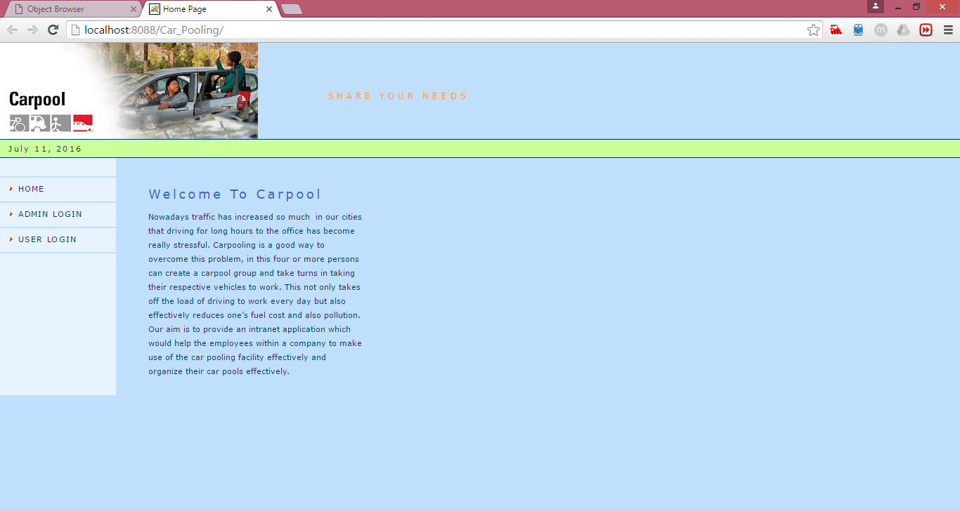
Description: This is the home page of carpool which shows welcome to carpooling website.
7.1.2Admin Login
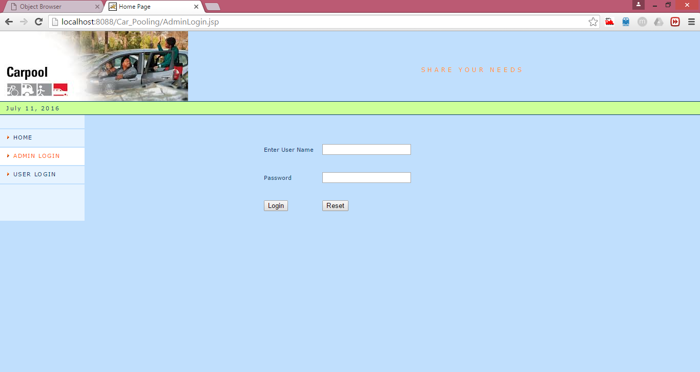
Description: The admin can log in into the system and can update the database by entering valid user name and password.
7.1.2.1 Validation & Messages
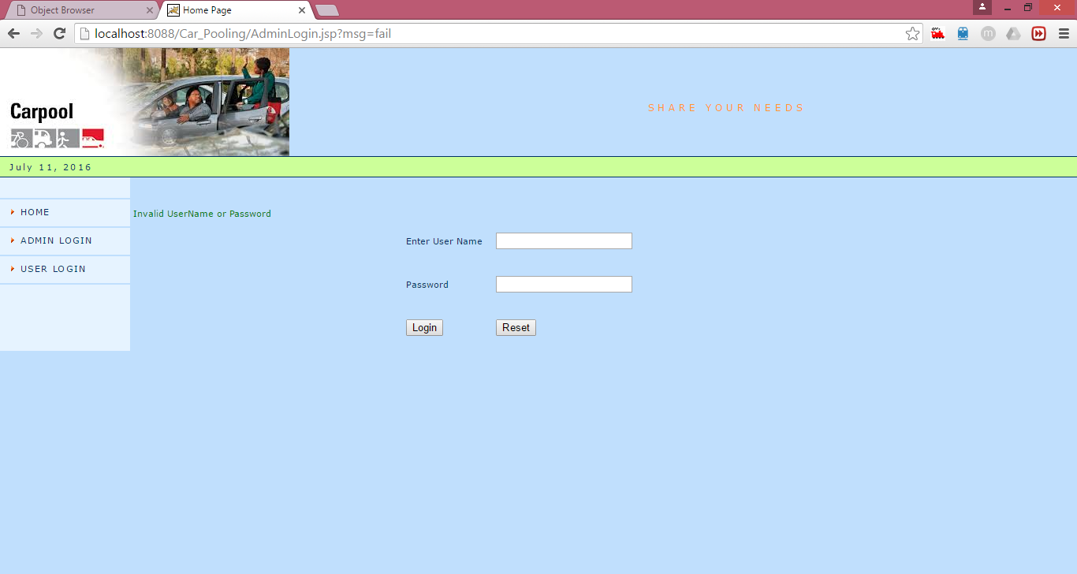
Description: The message will be displayed as invalid Admin name or password if he/she is not a valid admin.
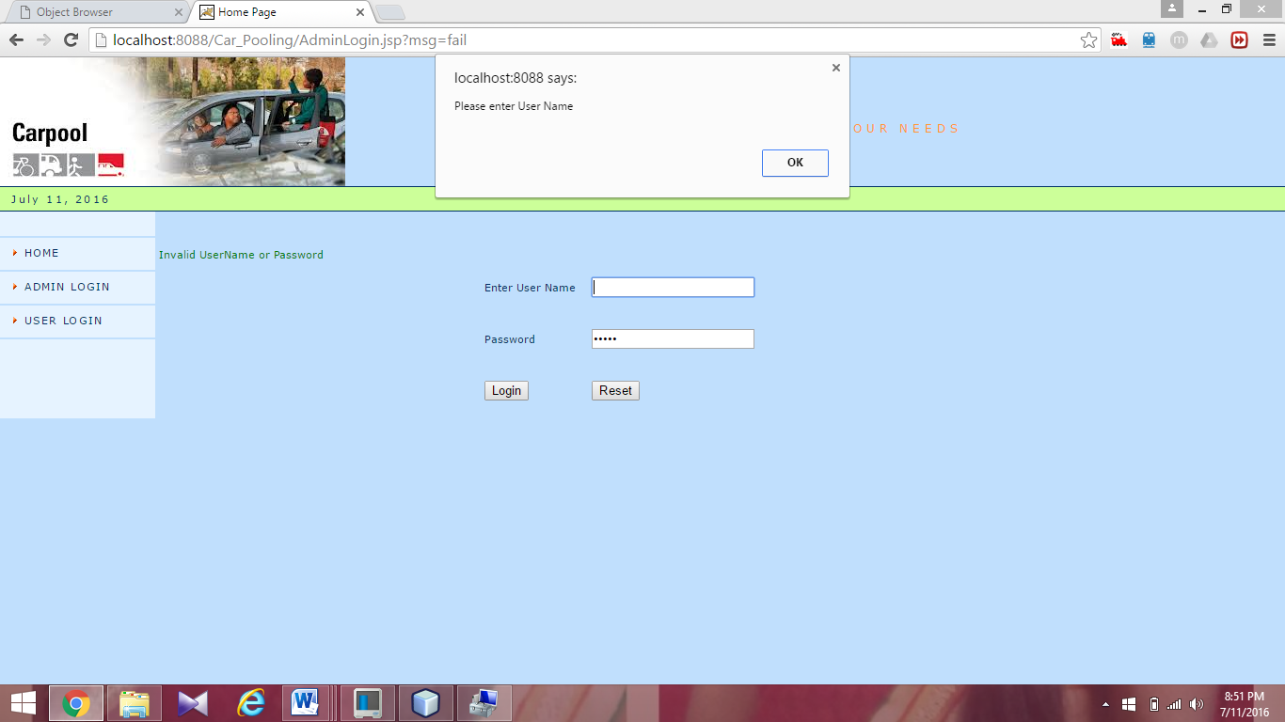
Description: The username should be entered otherwise it will display an alert box saying that please enter admin name.
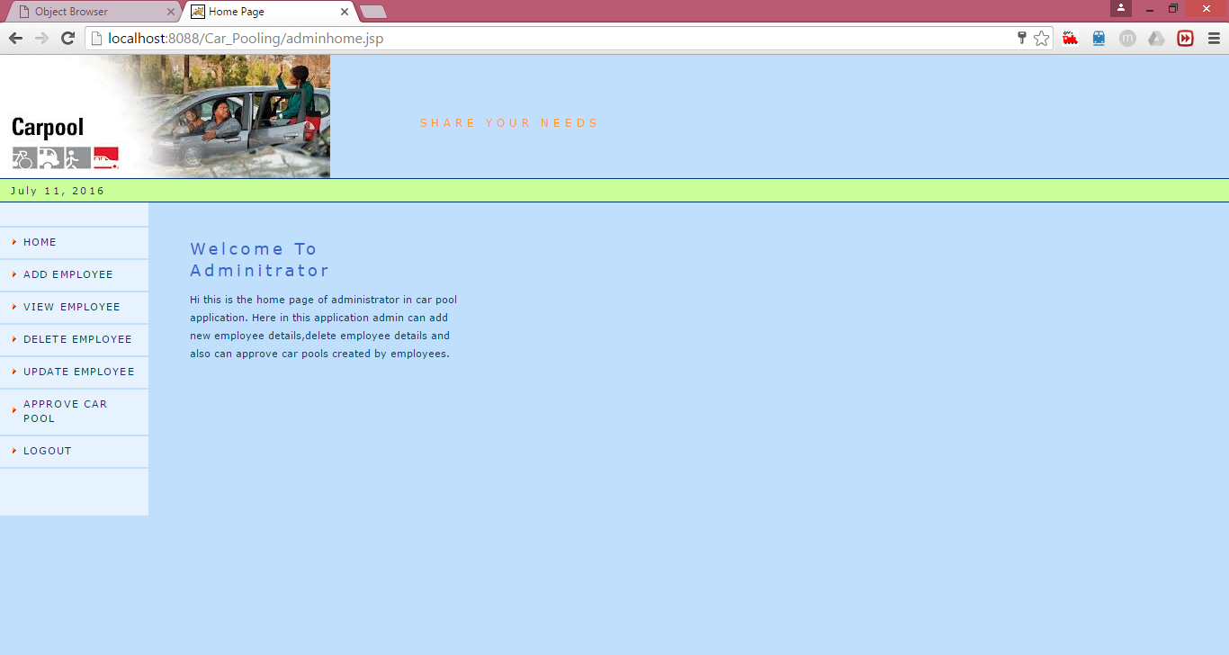
Description: If the correct admin name and password are entered it displays the authorized administrator page.
7.1.3 Employee Login
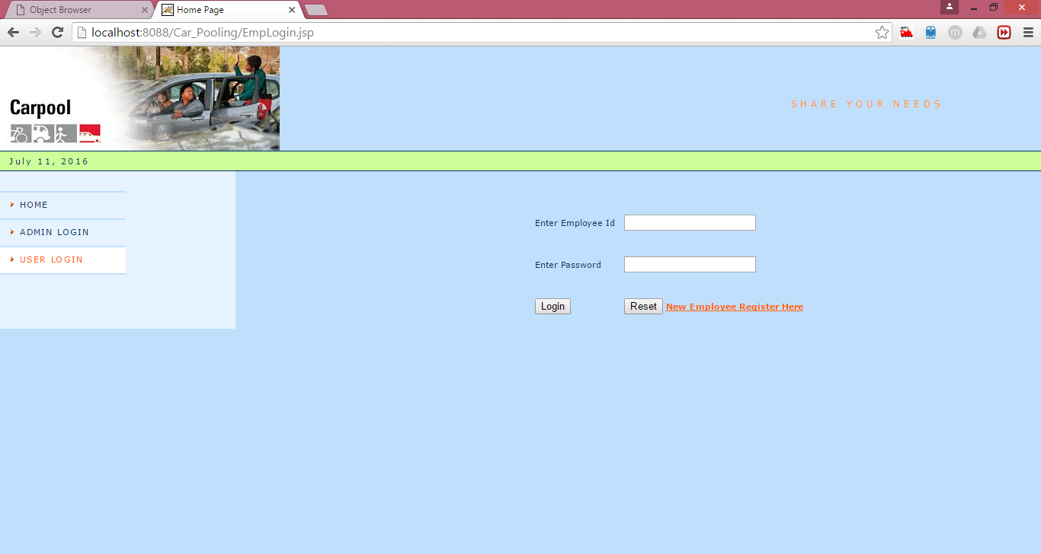
Description: The registered employee can log in to carpooling website by entering employee id and password.
7.1.3.1 Validation ScreenShots
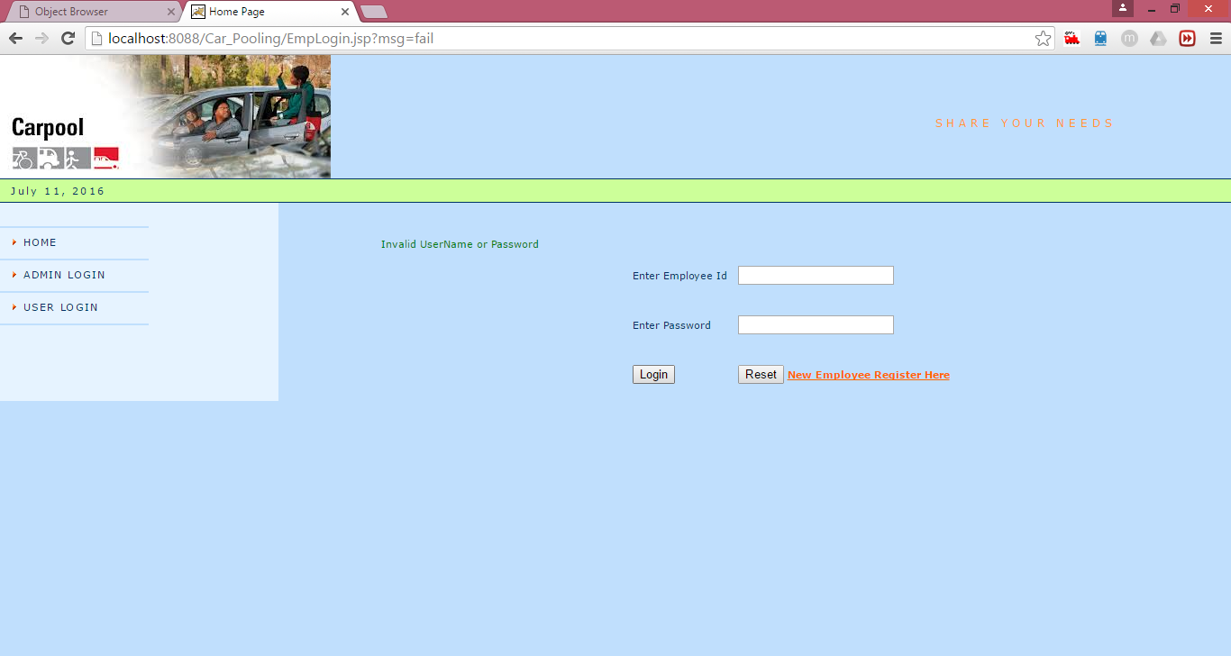
Description: The message will be displayed as invalid Username or password if he/she is not a valid user.
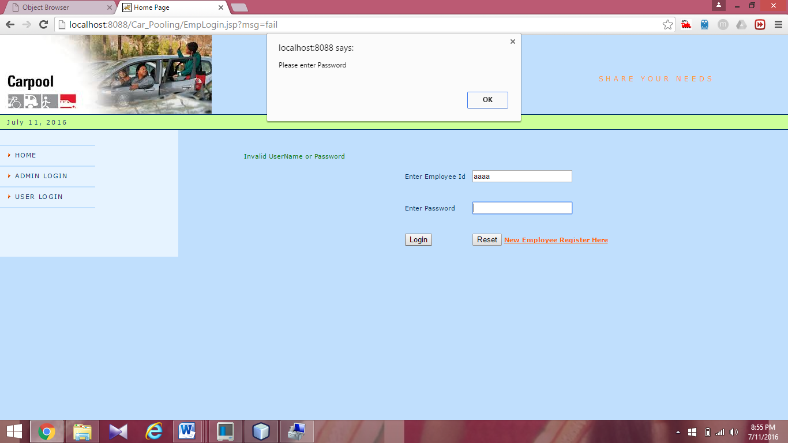
Description: The password should be entered otherwise it will display an alert box saying that please enter password.
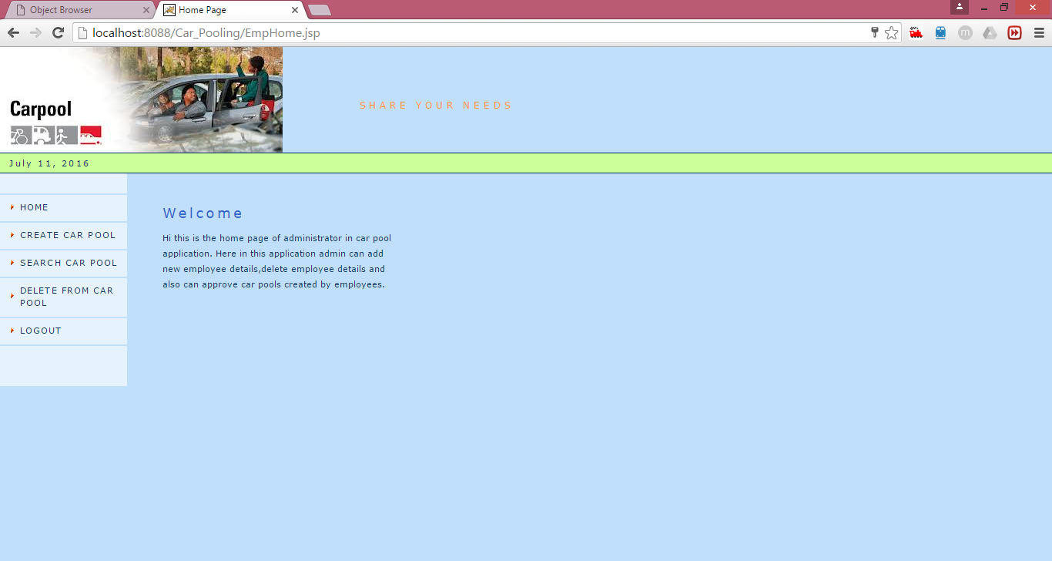
Description: If the correct employee name and password are entered it displays the authorized administrator page.
7.1.4 Employee Registration:
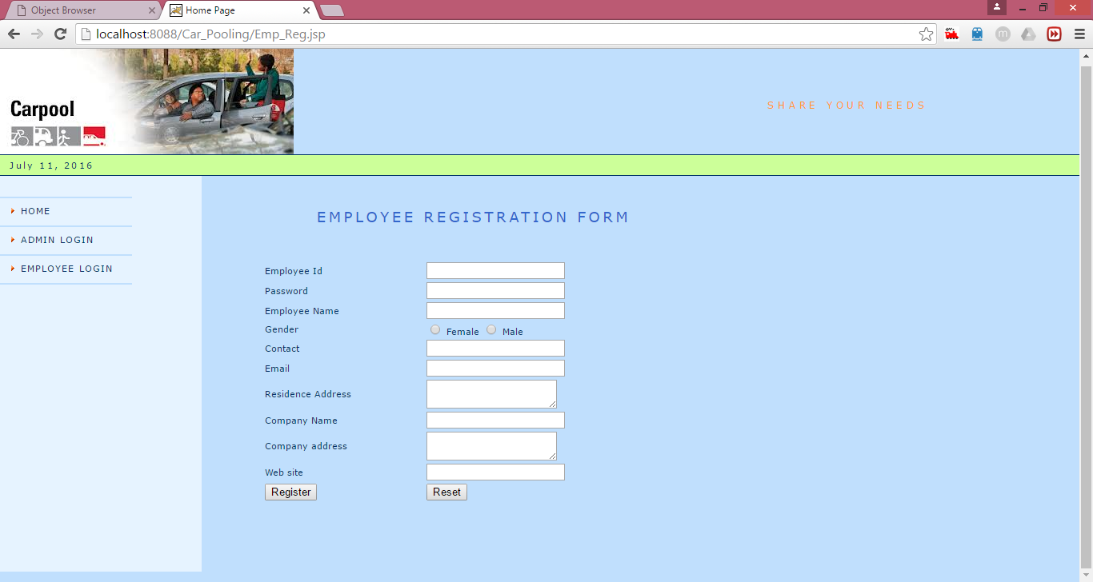
Description: The employee added by the admin can register in carpooling website.

7.1.4.1 Validation ScreenShots
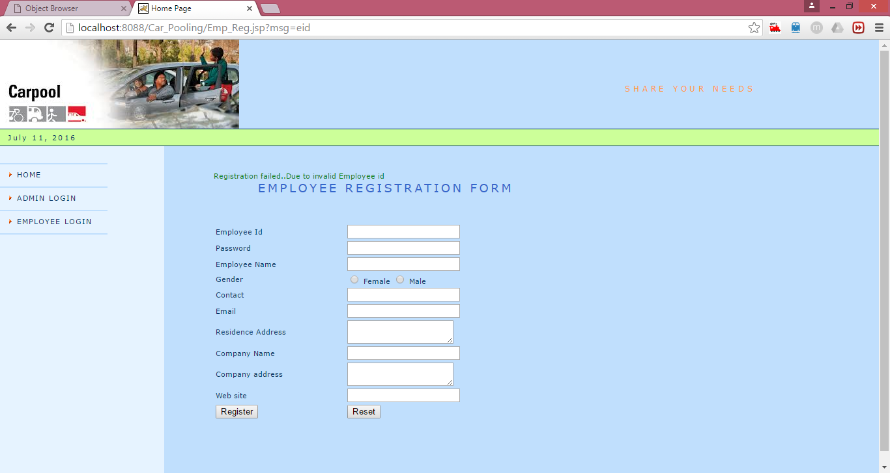
Description: The message will be displayed as registration is failed if he/she enters the incorrect Employee Id.
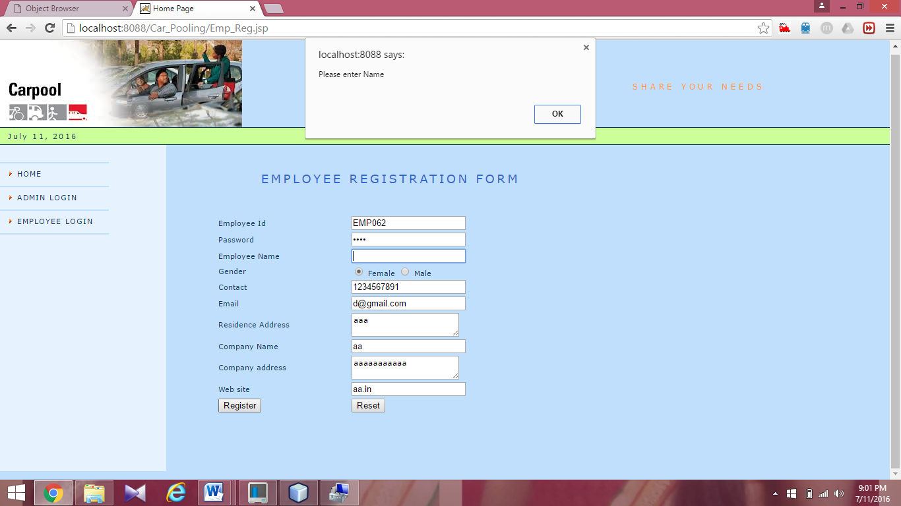
Description: The name should be entered otherwise it will display an alert box saying that please enter name.
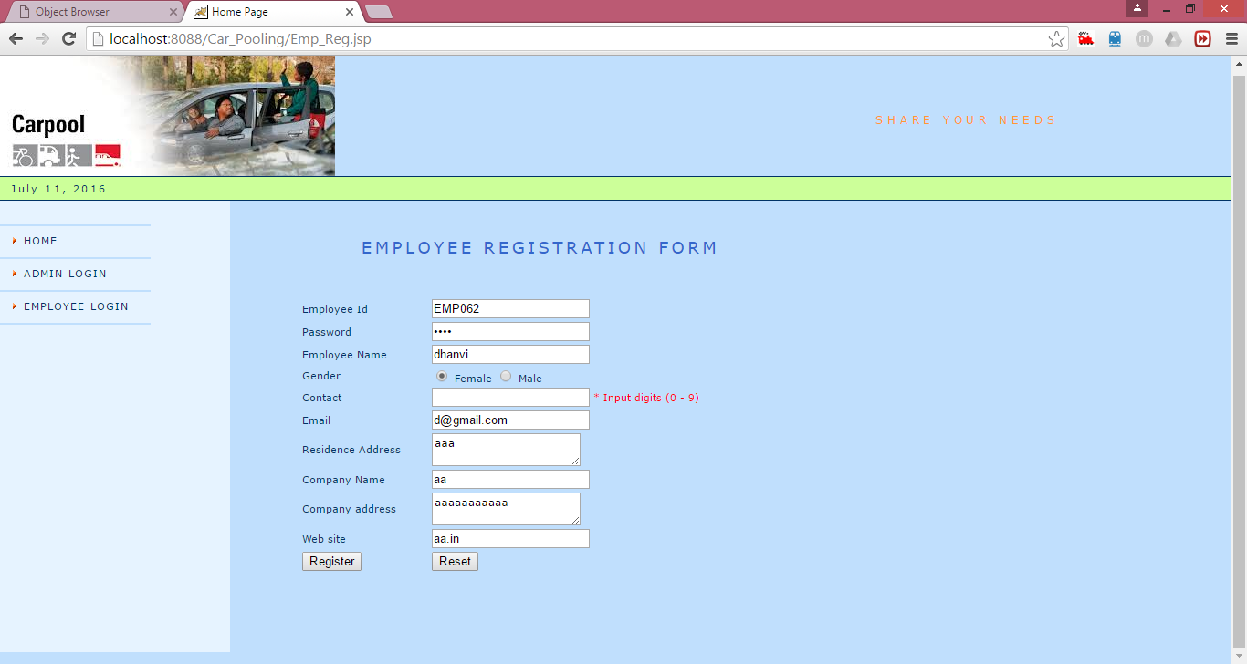
Description: The contact number should be entered in only numeric otherwise if any string is entered it will display an alert message as input digits from 0-9
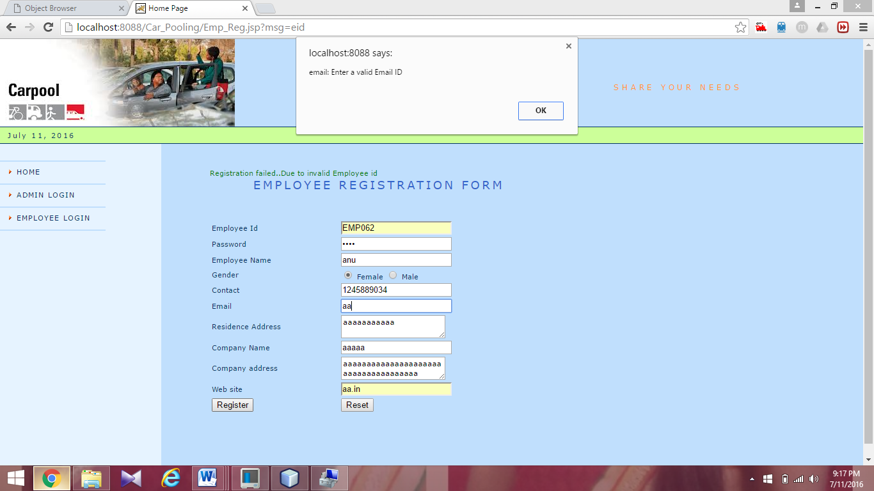
Description: The alert box is displayed enter a valid Email ID .If he/ she enters incorrect Email Id

7.2 Output Screens
7.2.1 Add Employee
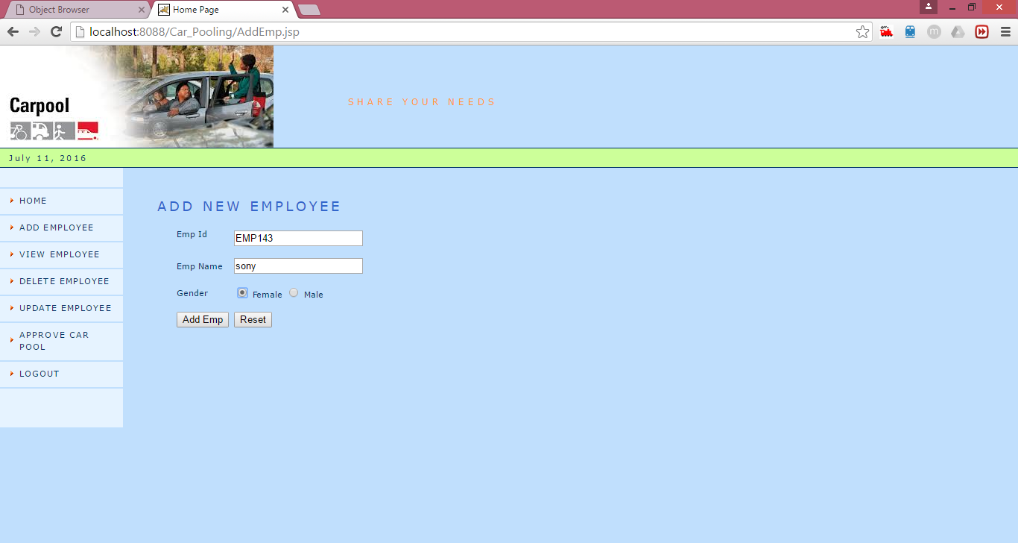
Description: Admin can add the employee by giving employee id.
7.2.2 View Employee
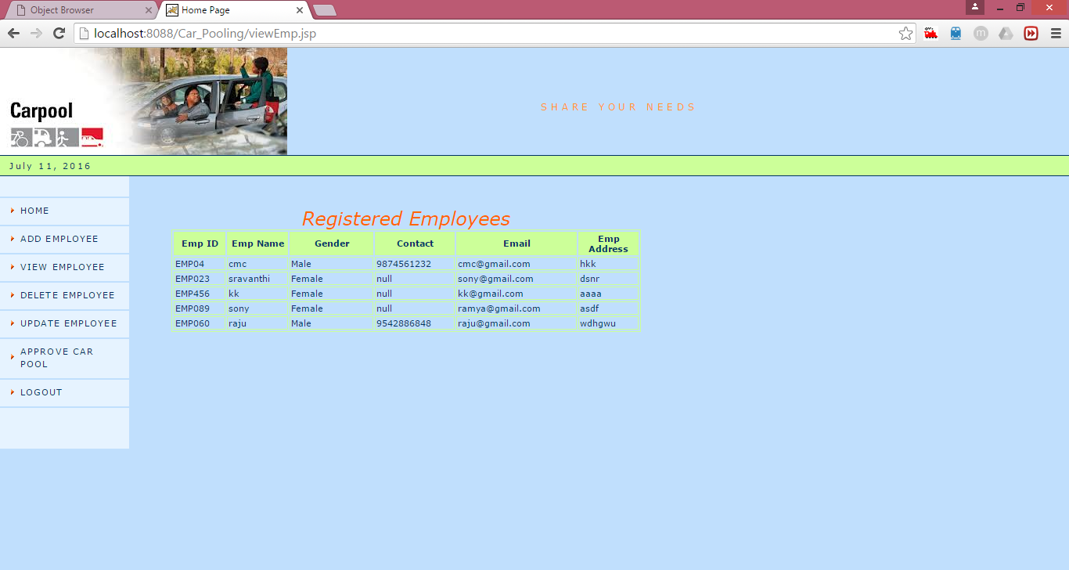
Description: Admin can view the details of registered employee’s.

7.2.3 Delete Employee
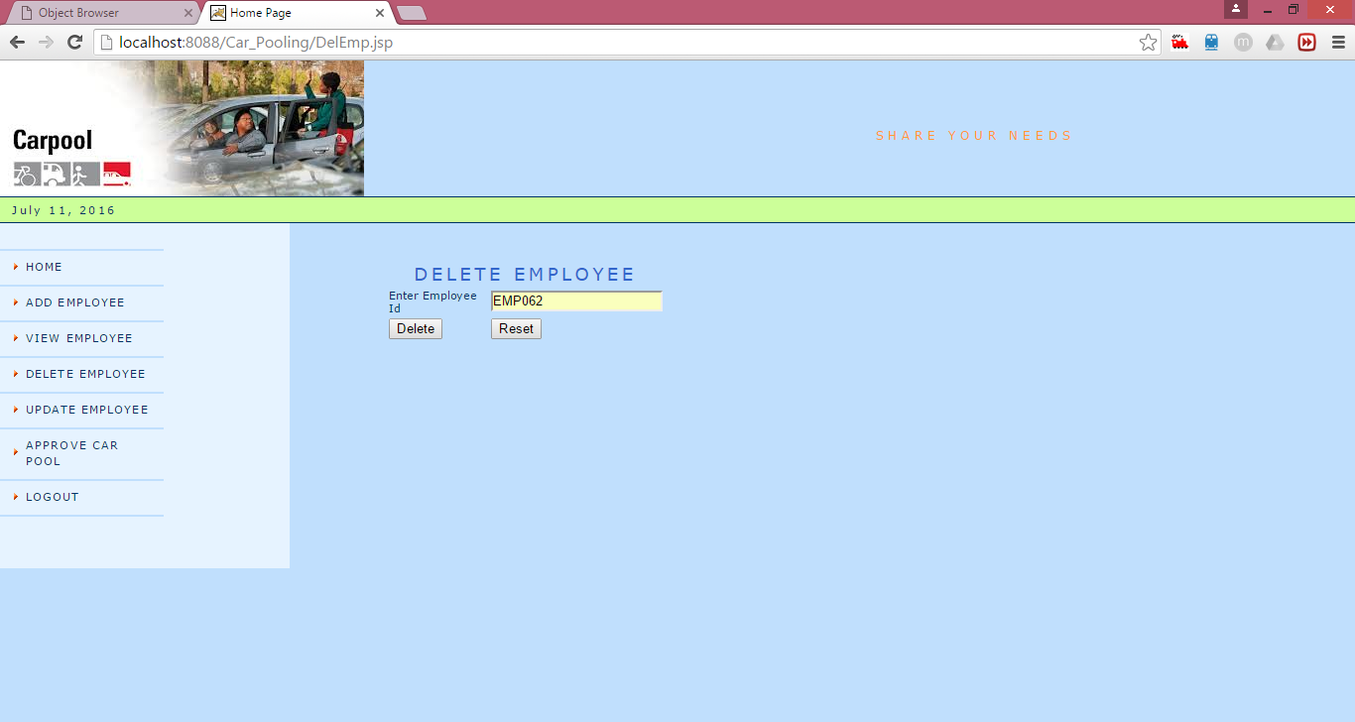
Description: Admin can delete the employee if required.
7.2.4 Update Employee
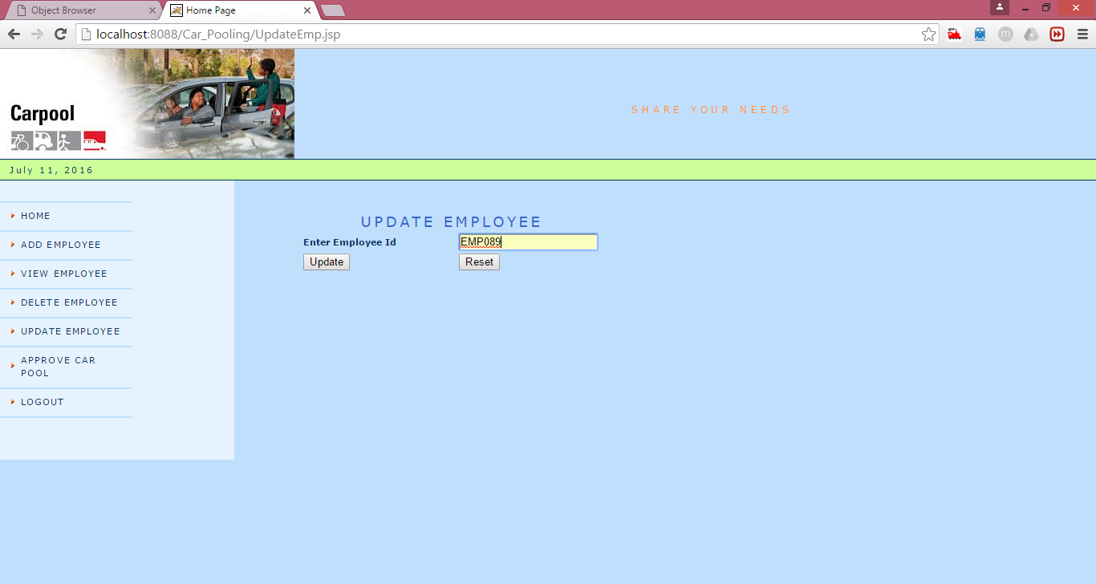
Description: Admin can update the employee details like name and gender if required.

7.2.5 Approve/Reject Carpool
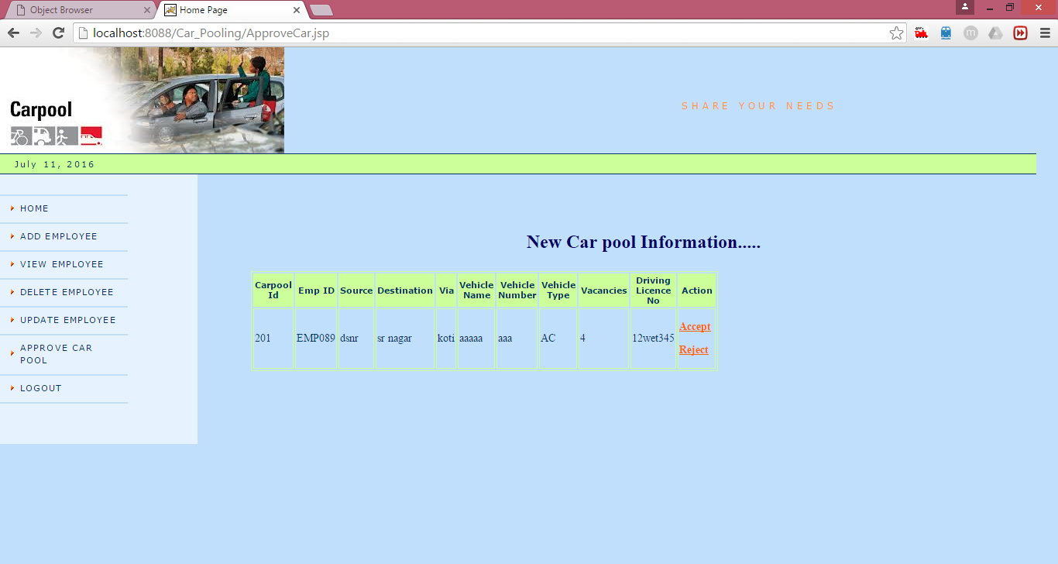
Description: Admin can accept or reject the carpool created by the user.
7.2.6 Create Carpool
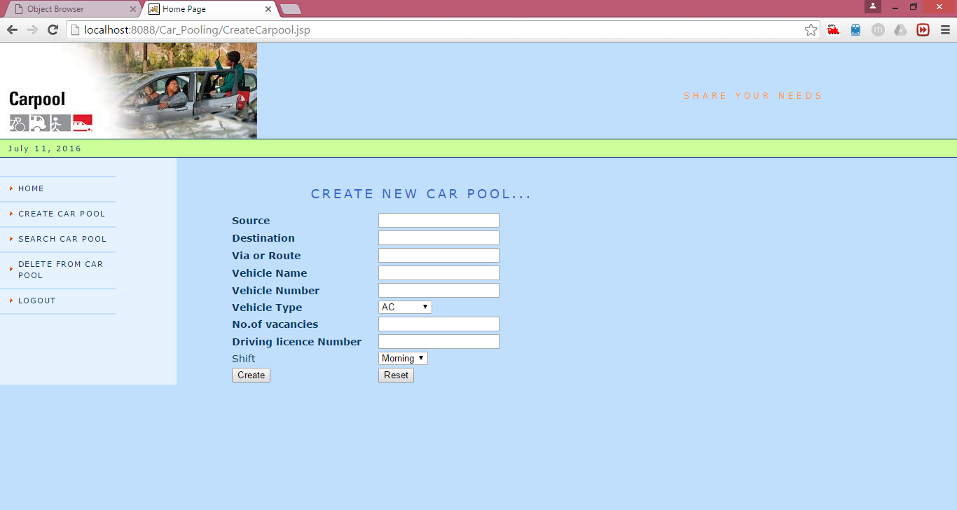
Description: The employee can create the carpool by giving carpool details like source, destination, via, vehicle name, vehicle number, vehicle type, no. of vacancies, driving licence number.

7.2.7 Search Carpool
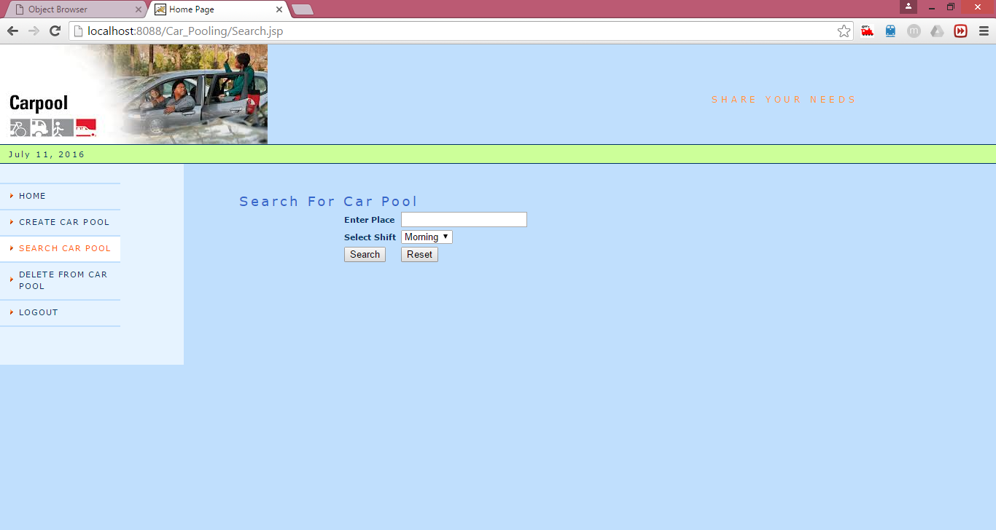
Description: The employee can search the carpool by giving the source.
7.2.8 Car pool Owner details
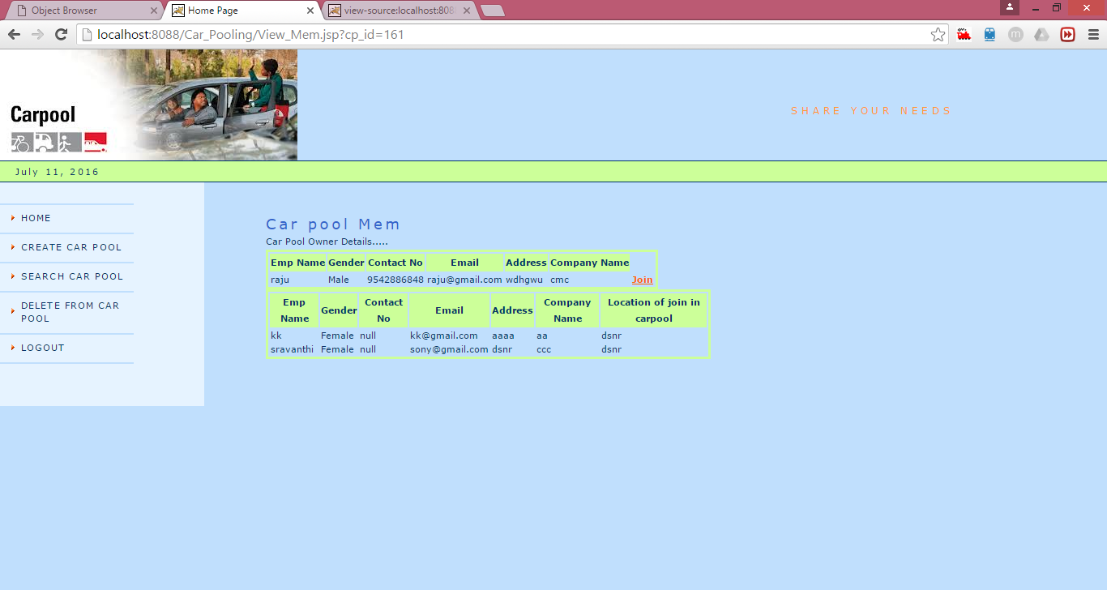
Description: The employee can view the car pool owner details and members of car pool. If he wish to join car pool then clicks on JOIN link.

7.2.9 Join in Car Pool
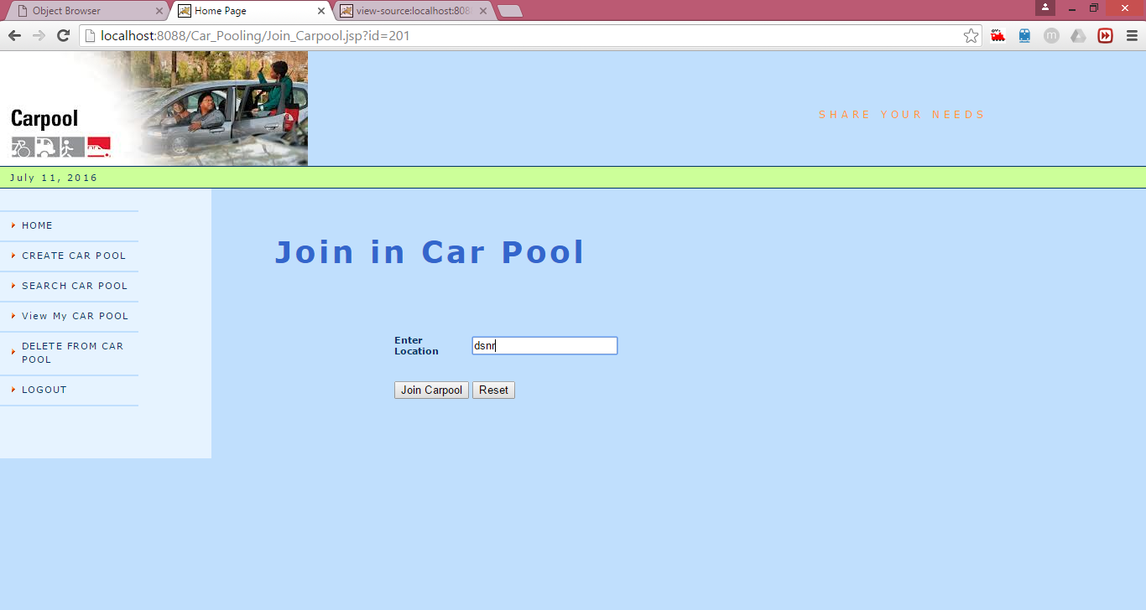
7.2.10 Delete From Carpool
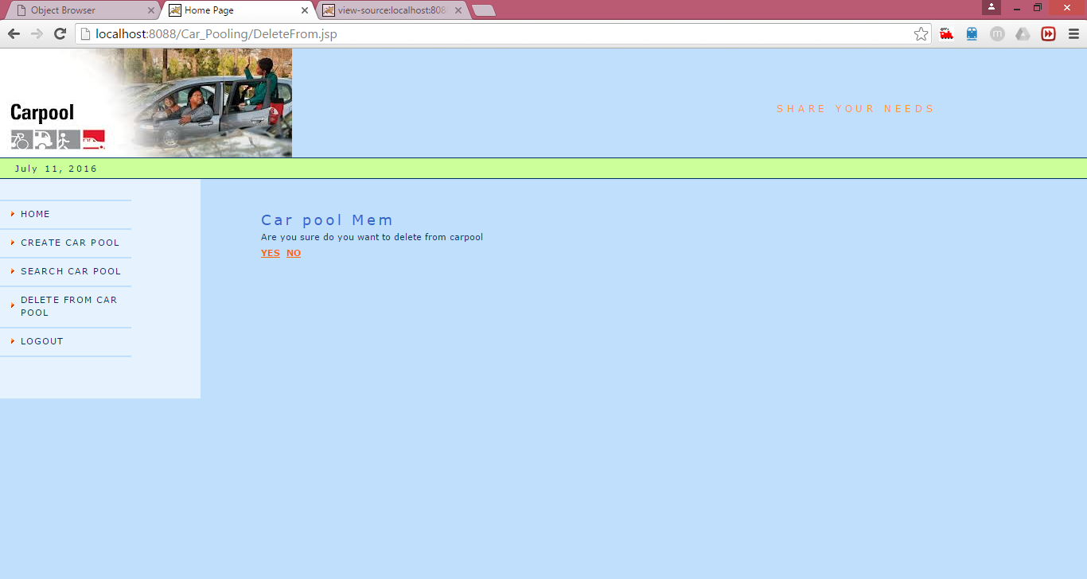
Description: The employee can be deleted from the carpool as per his/her wish

8. VALIDATION AND MESSAGES
8.1 Test Cases
8.1.1 Admin Login :
TEST  CASE | INPUT | EXPECTED RESULT | ACTUAL RESULT | STATUS  PASS/FAIL
1. | Enter the incorrect login id ,password | Displays message “invalid user name and password” | Displays message “invalid user name and password” | Pass
2. | Enter blank values | Displays an alert message “enter valid value for corresponding field” | Null values are checked with the database values | Pass
Table 8.1: Test Cases for Admin Login
8.1.2 Employee Login:
TEST CASE | INPUT | EXPECTED RESULT | ACTUAL RESULT | STATUS  PASS/ FAIL
1. | Enter the incorrect login id ,password | Displays message “ invalid user name and password” | Displays message “ invalid user name and password” | Pass
2. | Enter blank values | Displays an alert message “enter valid value for corresponding field” | Null values are checked with the database values | Pass
3. | Enter the correct login id and password | Displays authorized action to user | Displays authorized action to user | Pass
Table 8.2: Test Cases for Employee Login
8.1.3 Employee Registration
TEST CASE | INPUT | EXPECTED RESULT | ACTUAL RESULT | STATUS  PASS/FAIL
1. | Enter the incorrect field values | Displays an alert message “ invalid user name and password” | Displays an alert message “ invalid user name and password” | Pass
2. | Enter blank values | Displays an alert message “enter valid value for corresponding field” | Null values are stored in the database | Pass
Table 8.3: Test Cases for Employee Registration
8.2.1 Admin Login:
SNO | Field Name | Validations | Messages
1 | Username | Should enter username | Enter Username
2 | Password | Should enter password | Enter Password
Table 8.4 Test Cases for Admin Login

8.2.2 Employee Login
SNO | Field Name | Validations | Messages
1 | Username | Should enter username | Enter Username
2 | Password | Should enter password | Enter Password
Table 8.5 Test Cases for Employee Login

8.2.3 Employee Registration:
SNO | Field Name | Validations | Messages
1 | EmpID | Should not be incorrect | Please Enter correct employee id
2 | Contact no. | Should not be String,not less than and greater than 10 digits | Enter numeric digits
3 | Ename | Should not be blank | Please enter the field
4 | Email ID | Should not be incorrect | Please Enter correct email id
Table 8.6: Test Cases for Employee Registration

9.CONCLUSION
The application is reliable to use and it is very robust. The system is also taken care of easiness to use. The project is full fledged and user friendly, End users will be lightened in using this software because it is easy to have reports. The system thus developed has given them satisfaction in working.
This system can easily be expanded in the near future. Any person familiar with the current exiting system can operate this new system without any training. This application can be utilized for testing other implementation with relevant standards.

10.Future Scope
Carpooling is becoming increasingly popular with its promise, personal convenience and social improvement.
In Future we can incoporate the following functions:
- Can Provide the Message Alerts
- Can Provide Password Encryption

11.BIBLIOGRAPHY

Java at Sun Microsystems., Inc - java.sun.com.
Java user site: www.java.com.
Java Community Process Program - www.jcp.com.
Java Virtual Machine Specifications, 2nd Ed. - Java.Sun.com
Java Upgrade Guide: Migrating From the Microsoft VM for Java to the Sun JRE - java.sun.com
Java Virtual Machine - Wikipedia Stack - Wikipedia
Java Virtual Machine Specifications, 2nd Ed. - Java.Sun.com
Java Upgrade Guide: Migrating From the Microsoft VM for Java to the Sun JRE - java.sun.com
http://java.sun.com/products/jsp/
http://www.webopedia.com/TERM/J/JDBC.html
Software Engineering, A practitioners approach, By Roger S Pressman

